PD_TC _07 - OrangeHRM_Personal Details _Enter the last Name with numeric characters

Launch the URL

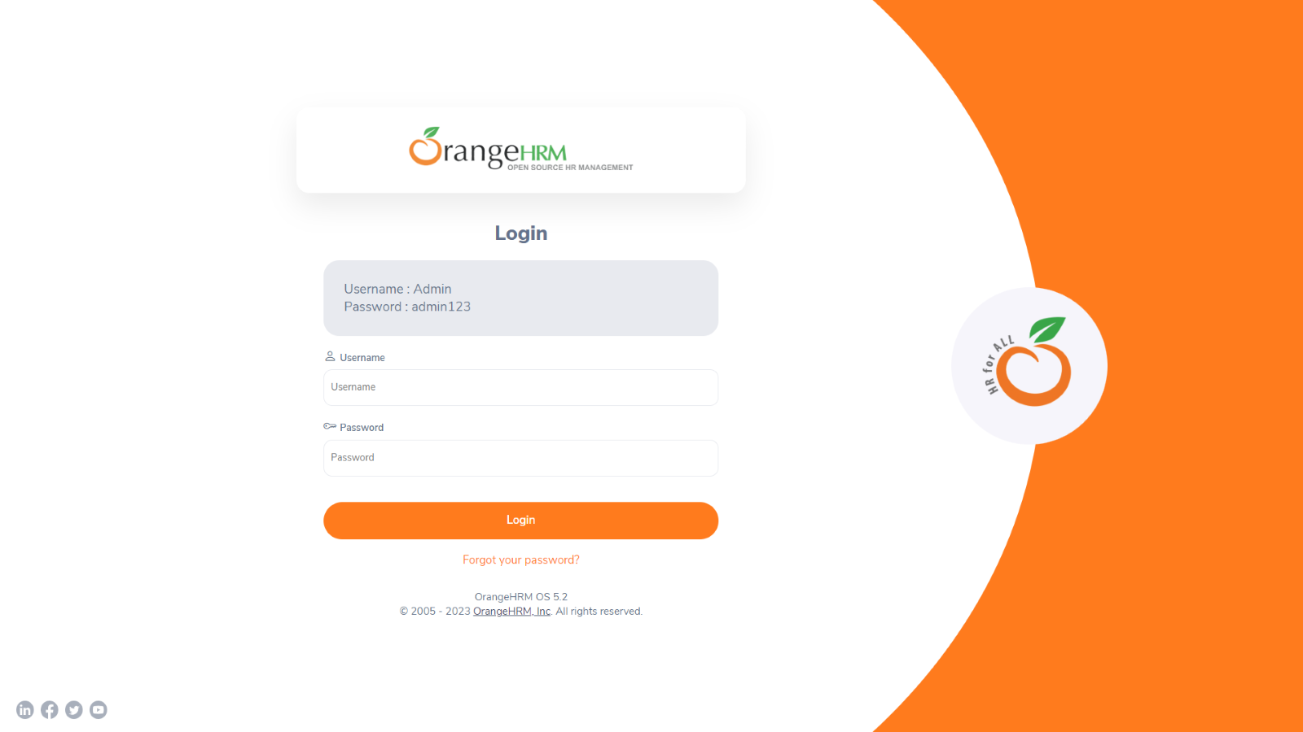

Login to the application with Valid credentials

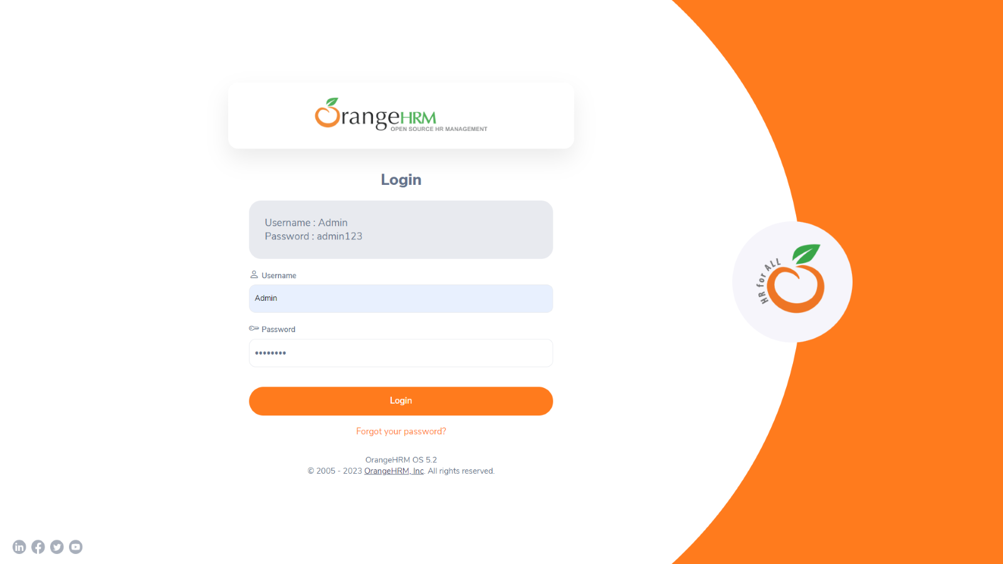

Logged successfully & navigated to personal details tab

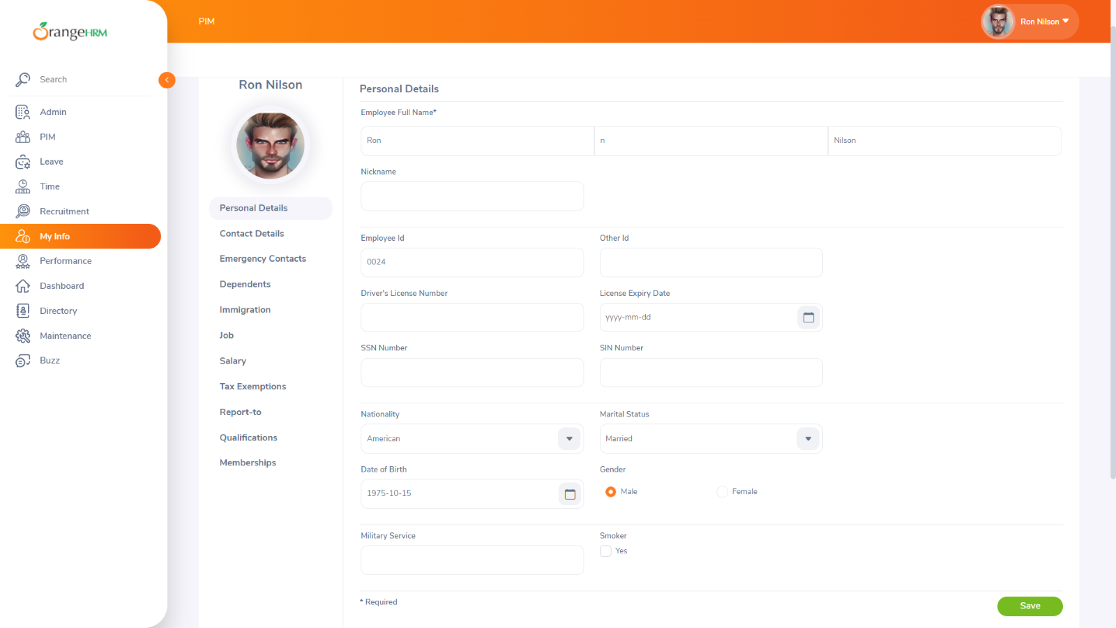Enter Enter the last Name with numeric characters

